



**For**

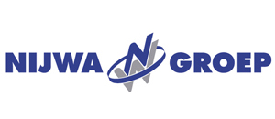

Proposal Document

Date: 22nd July, 2020 | Version V1.0

YOUR DIGITAL AUTOMOTIVE PARTNER

Table of Content

s

1. Introduction 3

2. Background 3

2.1. Purpose of this proposal - Nijwa Digital Transformation 3

3. Our Proposition - Alvarium 4

4. Alvarium Approach – Agenda for Nijwa 6

4.1. Team Composition 7

4.2. Organizational Roles & Responsibilities 7

5. Deliverables 8

6. Financial Proposal 9

6.1. Pricing 9

6.2. Payment Terms 9

7. General Terms & Conditions 10

8. Enclosures 10

# Introduction

**Nijwa Groep** (hereinafter called **Nijwa**) is an official dealer of Volvo Trucks and Renault Trucks and commercial vehicles in the Northern and Eastern Netherlands. They combine high-quality transport equipment with an excellent level of service. They are constantly developing new possibilities to let their customers drive sustainably, smartly and carefree.

**AutoFacets** **B.V.** (hereinafter called **AutoFacets**) is a Gateway Group Company, based in Zoetermeer, The Netherlands. AutoFacets is a leading Digital Automotive Partner for companies in the Automotive industry. With its rich portfolio of services, solutions and products, AutoFacets collaborate with automotive businesses for digital innovations that drive competitive edge.

# Background

The auto industry is facing a dynamic and potentially disruptive decade. New technologies and mobility offerings are reshaping how we use and drive vehicles. New players from the technology and connectivity sectors are entering the automotive & trucking industry, and the traditional auto value chain is under threat. Winners will be companies that streamline operations, build new capabilities, enter new businesses, and form smart partnerships to seize market opportunities.

With initial interactions with Nijwa Groep, Autofacets has understood the overall vision and roadmap of Nijwa Groep. Also, Autofacets has extensive experience in implementation of Business-critical solutions within the B2C and B2B segments. Hence, Autofacets and Nijwa Groep can jointly leverage the experience and take this initiative to the next level.

## Purpose of this proposal - Nijwa Digital Transformation

This proposal provides details on AutoFacets’ Alvarium proposition - a collaborative Design Led Transformation Consulting for visioning the digital transformation roadmap for Nijwa, along with Organizational Roles & Responsibilities bifurcation, Financial Proposition and General Terms and Conditions.

In view of significant change in the automotive ecosystem, with increasing challenges in consumer demands, technology development, globalization, integration and collaboration, Nijwa along with AutoFacets team, intends to take the initiative of defining the high-level Digital Transformation Strategy. During the initial discussion of AutoFacets with Nijwa Groep following critical focus areas were discussed:

1. Fleet Management System (FMS)
2. Repair, maintenance and tires (ROB) of trucks, trailers, vans, cars and tank containers
3. Strengthening Operations – OLP, DWO, Campaign Manager, Dynamic Pricing

Autofacets intends to envision the digitally transformed Nijwa business and to define the scope of transformation around the above mentioned area.

# Our Proposition - Alvarium

To achieve the goal of Digital Transformation, it is important to have a structured analysis to ensure identification of features & defining the scope for multiple programs. As a first step towards this, AutoFacets proposes **ALVARIUM** driven “Requirement Analysis” (RA) workshops/sessions to visualize the holistic vision for Nijwa Groep from Short l Mid l Long term perspective.

The objective is to undergo an end to end Digital transformation to achieve automation in a business ecosystem, resulting in increased business value, reduction in costs, optimized workforce, operational excellence and improved customer experience.

The aim of these workshops is to collectively visualize the market positioning of Nijwa Groep in future and accordingly co-create concepts and service models to achieve optimized operations, increased efficiency, and innovation driven market leadership in the automotive eco-system.

**Alvarium Phases:**

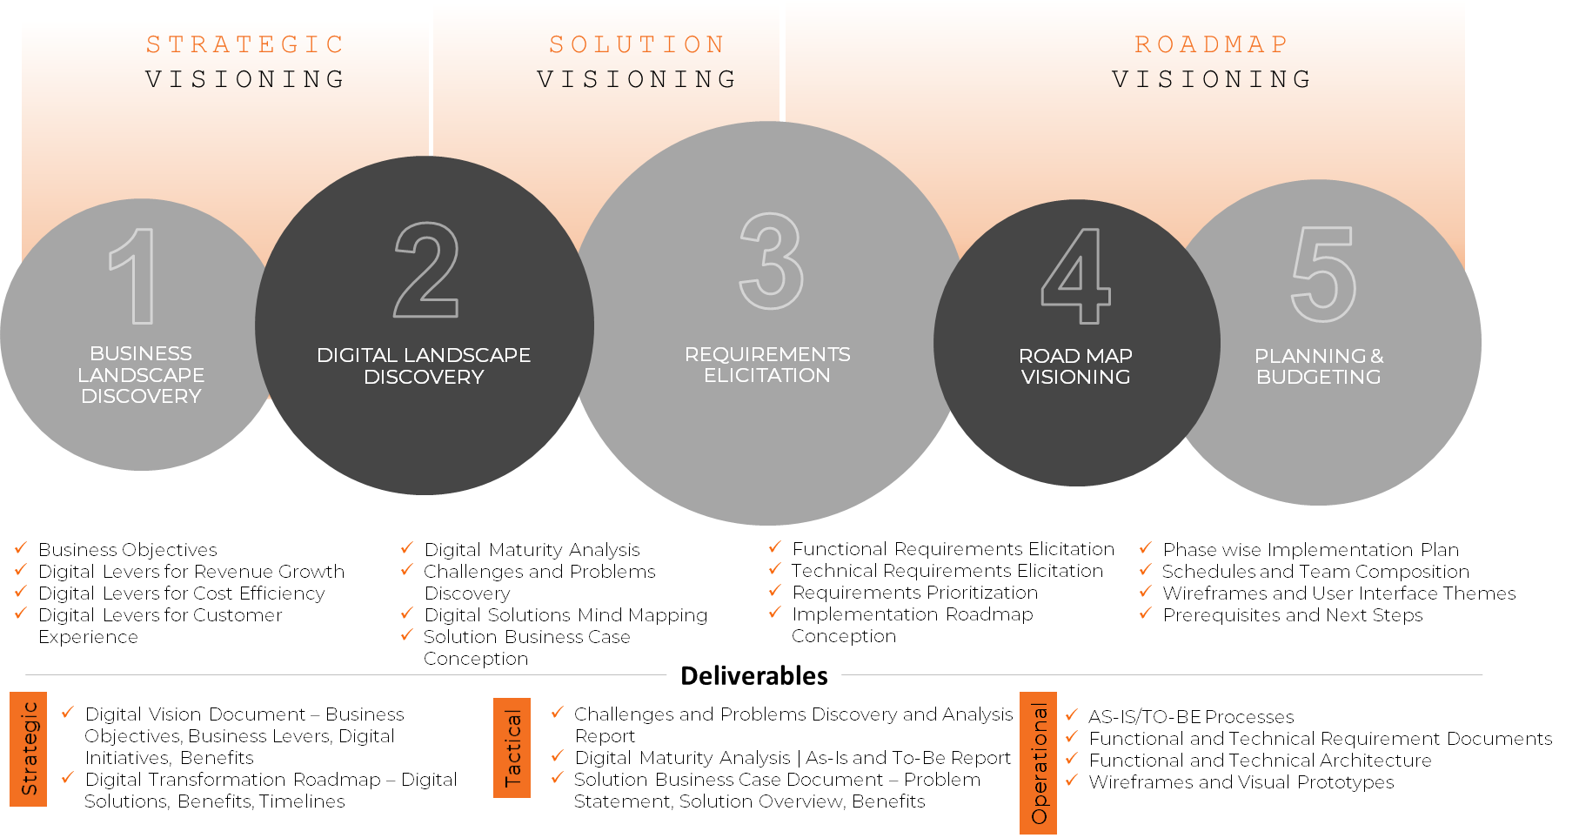

**Benefits of Alvarium:**

* Brings in innovation culture in the organization
* Practical insights to stakeholders about the organization's growth path
* Reduces risks with collaborative workshop engagement
* Identifies core problems and helps rectifying them
* Gain a different perspective to digital transformation
* Clear roadmap to your digital transformation journey
* Enabling to stay ahead of the curve by achieving your goals and objectives
* Crafting solutions tailored to your customer’s needs
* Helping you to stay relevant to changing markets and customer expectations

Alvarium is a methodology designed with the principle of revitalizing the potential of an enterprise in three fundamental phases as follows:

1. Strategic Visioning
2. Solution Visioning
3. Roadmap Visioning

Alvarium practice is inspired by the voice of more than 5000 Customers across 30+ Countries serviced and has been continuously improved over two decades.

**Creating Design led Digital transformation Roadmap**

The proposed focused areas for Nijwa Groep are aimed towards strengthening the 3 keys Pillars – People, Process and Platform. In order to achieve the overall objective of Nijwa Groep to be digitally ready and competitive with improvising Members/Suppliers experience, AutoFacets proposes to initiate the Alvarium workshops in a fixed price time boxed model. Below diagram shows a typical Alvarium journey and how we take our customers through a structured step by step method to create a digital transformation roadmap.

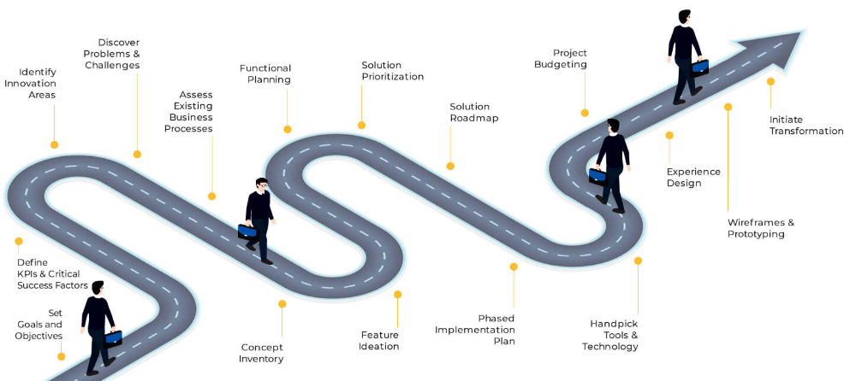

Duration of this Alvarium journey for Nijwa Groep will be ranged to **4 sessions** spanning through **4 weeks**, one session per week.

The focus will be on understanding Nijwa Groep business needs in order to support them to the fullest in their operations. Key objectives and 4 sessions are aimed towards:

* **Strategic Visioning:** Understand current Nijwa current it landscape
* **Solution Visioning 1:** Define 3 to 4 programs as per Nijwa priorities
* **Solution Visioning 2:** Requirement analysis/mapping of these identified programs
* **Roadmap Visioning:** Define roadmap and budget for these programs

# Alvarium Approach – Agenda for Nijwa

AutoFacets will conduct 4 Alvarium sessions jointly with Nijwa team and its relevant stakeholders. The detailed time table and workshop sessions agenda points have been described below. We have also mentioned various functional leaders needed for respective sessions.

Below is the tentative agenda of workshops:

|  |  |  |  |  |
| --- | --- | --- | --- | --- |
| **Session** | **I** | **II** | **III** | **IV** |
| **Date** | **24th August 2020** | **27th August 2020** | **7th September 2020** | **14th September 2020** |
| **Alvarium Phase** | **Strategic**  **Visioning** | **Solution Visioning -**  **Requirement Elicitation** | | **Roadmap Visioning –**  **Planning & Budgeting** |
| **Impact Functions from Nijwa** | **Strategy IT Operations Service Sales Marketing** | **Sales Marketing Service** | **Marketing IT Operations**  **Service** | **Strategy IT Operations Service Sales Marketing** |
| **Topic 1**  **(10 AM – 12 PM) CET** | * Business Model & IT Landscape of Nijwa * Digital Landscape Overview * SWOT Analysis * Application portfolio analysis | **Digital Journey mapping**   * Customer Journey analysis * Customer engagement challenges * Technology framework evaluation | **Digital Work Order**  **Smart Planner**   * Discuss the outcome of the requirement analysis * Solution Mind Mapping and Prioritization (MoSCoW) | **Consolidation & Presentation**  1. To-be digital landscape 2. Transformation roadmap 3. Project plans  - requirement analysis  - prioritized projects - design - implementation - deployment  - support & maintenance 4. Estimations 5. Schedules |
| **Topic 2**  **(01 PM – 03 PM) CET** | **Expectation Matrix Analysis**   * Nijwa expectation matrix * Fitment and scope for Nijwa Groep * Define 3 to 4 programs as per priorities | **Fleet Management Solution**  **Service, Maintenance & Repair Platform(ROB)**   * Data Sources Identification * Solution Mind Mapping and Prioritization (MoSCoW) * Mapping program/technology with current IT landscape | **To Be Landscape**   * Nijwa Groep To-Be Technical Architecture * Other 3rd party integration requirements - CRM, DMS etc. * Internal integration | **Next Step** - MSA – Master Service Agreement - SoW – Statement of Work for solutions - Nijwa Groep Feedback - Implementation Plan & Roadmap - Commercials |
| **Offline Work by Autofacets** | Processing | Processing | **IT-Feasibility** - Future Readiness and Recovery Plan - External Integrations Feasibility - Reusability analysis of Nijwa existing components/models |  |

***Note:*** *The above agenda is tentative and final agenda will be shared before the start of workshops.*

## Team Composition

Following table explains the team roles/composition for the proposed Alvarium:

|  |  |  |
| --- | --- | --- |
| # | Resource Type | Code |
| **1** | Onsite – Business Project Manager | BPM |
| **2** | Technical Lead | TL |
| **4** | Subject Matter Expert | SME |
| **5** | Business Analyst | BA |
| **6** | Technical Architect | TA |

***Note:*** Based on the progression during the Alvarium based RA phase, the team will be scaled as per requirement with mutual discussion between Nijwa Groep and AutoFacets.

## Organizational Roles & Responsibilities

**NIJWA Groep:**

1. Nijwa will appoint one Project Coordinator who shall be single-point contact to AutoFacets for all matters pertaining to the project development. He / She shall be responsible for the project related approvals.
2. Nijwa PoC will be responsible to collect and consolidate the inputs and information received from multiple stakeholders at Nijwa Groep and share the same with AutoFacets
3. Nijwa will help co-ordination with their stakeholders while analyzing the integration requirements.
4. Nijwa will be responsible for providing support documents related to the project during the Alvarium based RA phase.
5. Nijwa will be responsible for both making decisions and providing information in a timely manner.
6. The approval/feedback from Nijwa should take place within 1-2 working days from the day AutoFacets presents any material for approval/feedback. Any delay in the approval may result in delay of the project deliverables.

**AutoFacets:**

1. AutoFacets will be responsible for documentation of the understanding and specifications of the platform.
2. AutoFacets will deliver the necessary standard documented drafts which need to be reviewed and approved by Nijwa Groep. AutoFacets Project Manager would liaise with the Nijwa PoC for all requirements and clarifications.
3. AutoFacets shall suggest the approach for technical implementation and will be analyzed mutually between Nijwa and AutoFacets for final decision.
4. AutoFacets will be responsible for providing skilled professionals, matching to the job.

# Deliverables

As part of Alvarium Phase, AutoFacets will share with Nijwa Group the following deliverables:

1. To-Be Digital Landscape
2. List of features/functionalities- MoSCoW
3. Business Functional flow/User Flows
4. Technical Architecture
5. Estimates based on requirements per program
6. Implementation & release plan
7. Wireframes/NFP (3-4 Important screens only) of mutually agreed solutions

# Financial Proposal

## Pricing

The overall investment budget for the Alvarium based RA phase will be **€ 25,000, - ex VAT**.

**Payment Schedule**:

The payment schedule of Alvarium phase is as follow:

|  |  |  |  |
| --- | --- | --- | --- |
| # | Particular | % | Amount (€) |
| 1 | Payment at the time of signing contract | 50% | **€ 12,500** |
| 2 | Payment after 2 weeks of initiation | 50% | **€ 12,500** |
|  | **Total Cost** | **100%** | **€ 25,000** |

**Notes**:

1. Any changes to the proposed team composition will be mutually agreed and the pricing will be adjusted accordingly.
2. Travel & Stay will be on actuals.

## Payment Terms

1. The invoices will be raised as per payment schedule.
2. Offshore Rates are for team working from AutoFacets office in India.
3. Delivery Acceptance
   * **Interim Delivery**: For all interim deliveries, client will review & provide a formal "Delivery acceptance" within 07 working days from the date of delivery.
   * **Final Delivery**: For the final delivery, client will review & provide "Delivery acceptance" within 15 days from the date of delivery.
   * Any feedback on delivery issues, shall be communicated to AutoFacets and this will be addressed as per the priority mutually agreed upon.
   * Any change request (CR), should not impact the delivery acceptance of work already done and delivered.
4. The payment will be made within 15 working days from the date of receipt of Invoice. Non-payment within the due time, will result in postponement of activities by AutoFacets till payment is received.
   * Any outstanding amount will attract penal charges as per statutory interest.
   * In case of delay from Client, where resources will be idle, Client will bear the additional cost which will be as per rates agreed in Change Request.
5. The payment will have to be remitted to AutoFacets B.V. bank accounts in Netherlands through bank transfers.
6. All amounts are net amounts, excluding all kinds of tax, processing/ transfer fees. Such additional charges shall be borne by client.
7. All financial transactions will be done in the agreed currency mentioned in this proposal.
8. The proposal is valid for 15 days from the date of submission of this proposal.

# General Terms & Conditions

1. The General Terms and Conditions of AutoFacets Group as described in <AutoFacets T&C.pdf > (hereinafter referred to as "AutoFacets T&C") apply to this proposal, the same is attached herewith. The applicability of purchase conditions or any other conditions from the customer or from third parties is, then, expressly rejected. Customer explicitly declares to have received the AutoFacets T&C and by signing this document expresses the willingness to agree with AutoFacets T&C.

2. Specifically mentioned conditions in this document supersedes the AutoFacets T&C.

We hope that by means of this proposal, we have met the expectations of **NIJWA** and look forward to mutually beneficial business cooperation. We kindly request you to sign one set of documents and return it back to us.

Sincerely,

|  |  |
| --- | --- |
| On behalf of AutoFacets | On behalf of Nijwa Groep for acceptance |
| **AutoFacets B.V.**  Name: Mr. Vipin Moharir  Designation: Director    Signature:  Date: | **Nijwa Groep**  Name:  Designation:  Signature:  Date: |

# Enclosures

Following are the supporting documents submitted as enclosures to this proposal. The same are available as email attachments along with this proposal.

1. AutoFacets Terms and Condition: <AutoFacets T&C.pdf >

*** End of the document

****Confidentiality****

**This document and any files with it are for the sole use of the intended recipient(s) and may contain confidential and privileged information. If you are not the intended recipient, please destroy all copies of the document. Any unauthorized review, use, disclosure, dissemination, forwarding, printing or copying of this document or any action taken in reliance on this document is strictly prohibited and may be unlawful. Visit us at** [http://www.AutoFacets.com/](http://www.translogtec.com/)



****Confidentiality****

**This document and any files with it are for the sole use of the intended recipient(s) and may contain confidential and privileged information. If you are not the intended recipient, please destroy all copies of the document. Any unauthorized review, use, disclosure, dissemination, forwarding, printing or copying of this document or any action taken in reliance on this document is strictly prohibited and may be unlawful. Visit us at** [http://www.AutoFacets.com/](http://www.translogtec.com/)

****Confidentiality****

**This document and any files with it are for the sole use of the intended recipient(s) and may contain confidential and privileged information. If you are not the intended recipient, please destroy all copies of the document. Any unauthorized review, use, disclosure, dissemination, forwarding, printing or copying of this document or any action taken in reliance on this document is strictly prohibited and may be unlawful. Visit us at** [http://www.AutoFacets.com/](http://www.translogtec.com/)

****Confidentiality****

**This document and any files with it are for the sole use of the intended recipient(s) and may contain confidential and privileged information. If you are not the intended recipient, please destroy all copies of the document. Any unauthorized review, use, disclosure, dissemination, forwarding, printing or copying of this document or any action taken in reliance on this document is strictly prohibited and may be unlawful. Visit us at** [http://www.AutoFacets.com/](http://www.translogtec.com/)

****Confidentiality****

**This document and any files with it are for the sole use of the intended recipient(s) and may contain confidential and privileged information. If you are not the intended recipient, please destroy all copies of the document. Any unauthorized review, use, disclosure, dissemination, forwarding, printing or copying of this document or any action taken in reliance on this document is strictly prohibited and may be unlawful. Visit us at** [http://www.AutoFacets.com](http://www.autofacets.com/)

**The Netherlands (HQ)**

1st floor, Maria Montessorilaan 5,

2719 DB Zoetermeer, Netherlands,

**Phone:** +31 79 3200 980  
**E-mail:** info@autofacets.com

**Germany**

Südstraße 32-34

D-31515 Wunstorf,

Hanover

**United Kingdom**

Landmark House, Station Road, Hook" RG27 9HA Hampshire

**Finland**

Tekniikantie 14 2110

Espoo

**France**

9 Boulevard,

du Chateau 92200,

Neuilly-sur-Seine, Paris

**Sweden**

Järnvägsgatan 36,

131 54 Nacka, Sverige

**Norway**

House of Business,

Fridtjof Nansens plass 4"

160 Oslo

**Iceland**

Jónsgeisla 35,

113z Reykjavík

**North America**

2651, Pearland Parkway,  
Suite 102, Pearland,  
Texas 77581

**Japan**

1-12-8 Shintomi,

Chuo-ku,

104-0041 - Tokyo